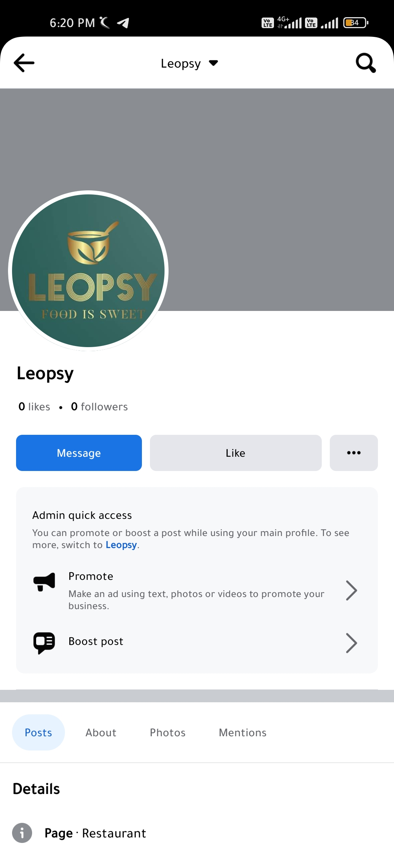**ASSIGNMENT-2**

Create a New Facebook Business Page and Post one social media poster for your brand.

|  |  |
| --- | --- |
| NAME | **Bharath Srikanth.p** |
| NM ID | 1DB94440FC7FB40AE9E49813F967D58A |
| ASSIGNMENT 2 | Create a New Facebook Business Page and Post one social media poster for your brand |

